**Data and Control flows implemented in Talend :**

1. Department Dim

1. Regulation Dim:

1. Equipment Dim:

1. Supplier Dim:

Tmap:

Type-2 SCD:

1. MaintenanceTechDim:

Tmap:

Type-3 SCD:

1. DecommissiongDim:

Tmap-1:

Tmap-2:

1. State:

Tmap:

1. AllocationDim:

1. City:

Tmap-1:

1. MaintenanceFact :

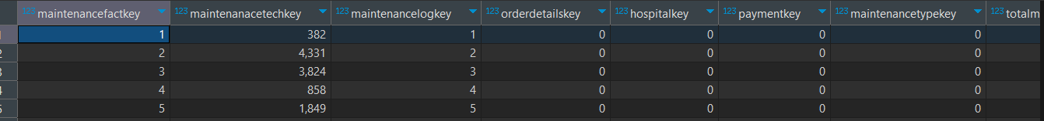

1. HospitalDim:

T-map1 :

1. Itemdesc:

1. Maintanencelogdim:

T-map1:

SCD Type3 :

1. Maintanencetypedim :

1. Monthyear:

1. Orderdetailsdim :

t-map1:

1. Patientdim:

1. PaymentDetailsdim:

1. SpareinventoryDim:

1. State :

1. Useraccess:

1. Yeardata:

1. SupplierFACT:

**Analytical Queries :**

1. **A screenshot of a computer program

   Description automatically generatedTop 3 paid maintenance Technicians :**
2. **A screenshot of a computer

   Description automatically generatedList user access levels and the access they have.**

1. **Total maintenance cost to the healthcare/hospitals :**

